CS 315 Data Structures Fall 2008

Project # 2

Due: October 3, 2008

Problem Statement: Write a C++ program to perform the following operations on an image: (a) add a text label to the upper right corner as foreground and (b) apply a recursive transformation that produces several copies of the image and tiles them on a frame of the same size as the original image.

The following figure illustrates the input and the output files for operation (a):

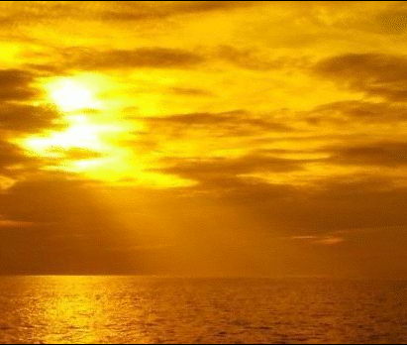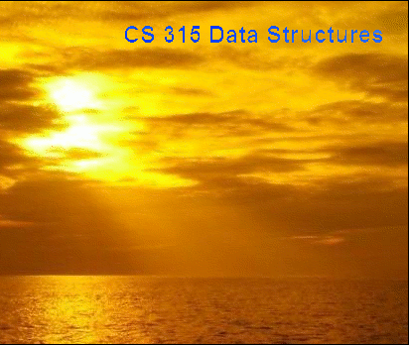

The next figure illustrates the required operation (recursive transformation) for problem (b):

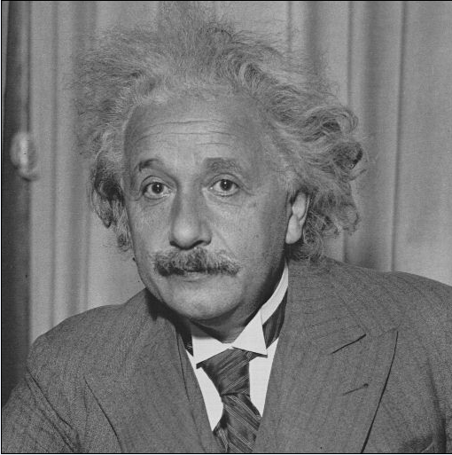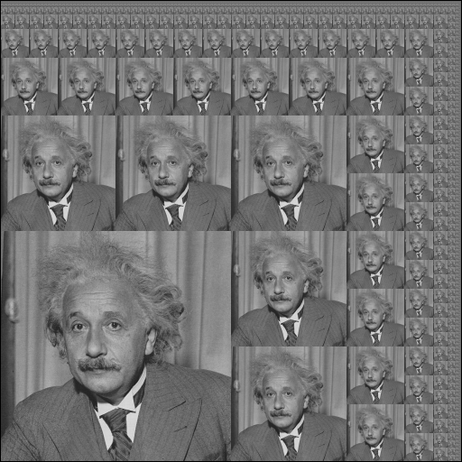

Goals of the project:

- learn to use a C++ library designed for image manipulation. (We will continue to use the package in other labs to learn some image processing algorithms.)

- learn to use recursion to generate a fractal-like image pattern.

EasyBMP library:
EasyBMP is a library written in C++ that provides support for opening an image (in the BMP format), and manipulate the individual pixels of the image. You don’t have to know the details of how a BMP image is stored in a file. It is enough to know how to make calls to EasyBMP functions. The following are some useful classes and functions from the EasyBMP library:
- RGBApixel
A class that represents a single colored pixel. Each pixel is determined by four color components -- red, green, blue, and alpha. Each of these color components is an unsigned char variable (i.e. an integer between 0 and 255), and is accessed as follows: if v is a pointer to an RGBApixel variable, then the relevant color components can be accessed using v->Red, v->Green, v->Blue, and v->Alpha, respectively.
- BMP
A class that holds a bitmap image, i.e. a rectangular array of colored pixels (i.e. RGBApixel objects). Once you define a variable of type BMP, you can then manipulate it using the functions listed below.
- bool BMP::ReadFromFile(const char* FileName)
Given the name of an image file, this function loads the image into the BMP class, so that your program can then access the image using member functions listed below. The function returns a bool value indicating whether the read was successful.
- bool BMP::WriteToFile(const char* FileName)
If you want to save the image in your program to disk, this function allows you to do so; you specify the desired filename as the argument to the function. The function returns a bool value indicating whether the write was successful.
- int BMP::TellWidth()
This member function takes no inputs, and returns the number of pixels in the horizontal direction.
- int BMP::TellHeight()
This member function takes no inputs, and returns the number of pixels in the vertical direction.
- RGBApixel* BMP::operator()(int i, int j)
This is an example of an overloaded operator. Here the parentheses have been overloaded, so that given img is an object of type BMP, the expression img(i,j) returns a pointer to the color information stored at the pixel whose x-coordinate is i and whose y-coordinate is j. The upper-left-hand pixel is given by i = 0, j = 0 and the positive x-axis is West to East while the positive y-axis is from North to South.
To get a more detailed account of the package, read the manual EasyBMP_User Manual.pdf may be useful. You can get the manual from the web site http://easy bmp.sourceforge.net/documentation.html. The manual contains some examples with source code. Of particular interest is the first example that shows how to combine two images.
In the following, a simple example is presented to illustrate the use of EasyBMP.
Suppose we want to convert a color image or a gray scale image into black and white. Such an algorithm is useful to create a bit-map image to print a color photograph on a black and white printer. We will use a very simple algorithm called thresholding. Recall that each color pixel is defined by three color components (R, G, B), each taking a value between 0 and 255. R = G = B = 255 is white, R = G = B = 0 is black. In thresholding, the weighted average of the color components of a pixel (a R + b G + c B)/ (a + b + c)) is computed and if this average exceeds 127, the pixel is mapped to white, otherwise it is mapped to black. In the code below, we use the weights a = 0.3, b = 0.6 and c = 0.1 (since green is the most sensitive and blue is the least sensitive.) We present the code to implement this algorithm below.
An example of input/output is shown below.
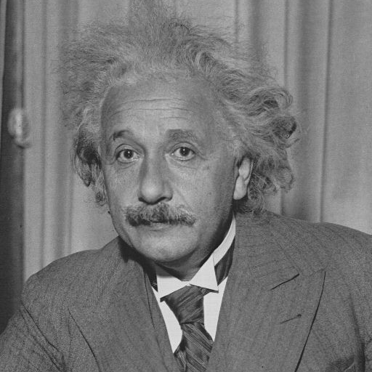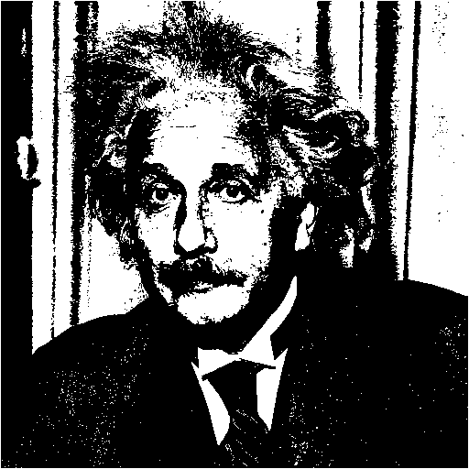
The code is as follows:

#include "EasyBMP.h"
using namespace std;

int main( int argc, char* argv[] )
{
BMP Background;
Background.ReadFromFile(argv[1]);
BMP Output;
int picWidth = Background.TellWidth();
int picHeight = Background.TellHeight();
Output.SetSize(picWidth, picHeight);
Output.SetBitDepth(1);

for (int i = 1; i < picWidth-1; ++i)
for (int j = 1; j < picHeight-1; ++j) {
Output(i,j)->Red = 0;
Output(i,j)->Blue = 0;
Output(i,j)->Green = 0;
}

for (int i = 1; i < picWidth-1; ++i)
for (int j = 1; j < picHeight-1; ++j) {
int col = 0.1* Background(i, j)->Blue +
0.6*Background(i,j)->Green +0.3* Background(i,j)->Red;
if (col > 127) {
Output(i,j)->Red = 255;
Output(i,j)->Blue = 255;
Output(i,j)->Green = 255;
}
}
Output.WriteToFile(argv[2]);
return 0;
}
Solution to the two problems:
Problem (1)
To label the given image with a given text, you need access to a bit-map image of each letter. We will assume that the label uses the letters A … Z, 0 … 9 and blank and that the font images are black in a white background. Assume that font images are in the same directory as the source code. The basic idea is to first copy the background image onto a buffer. Then, your program should overwrite the pixels on the upper-right corner by copying the bit-map images corresponding to the label. For example, if the label is the word “text”, your program will calculate the position at which each of the letters t, e, x and t should be written. It should then copy the image t.bmp, e.bmp etc. to the appropriate position. When you write a letter on the image you should use the following rules:
(a) only the letter (not the background) should be copied
(b) the color you use for the image should be complementary to the color of the background of the image and
(c) the font images need not be scaled. You can assume that their heights are the same but their widths are not. You should use the width information to find the correct position to place each character. (Allow a top and a right margin of 15 pixels.)
If the space needed to typeset the label exceeds the width of the image, your program should display an error message and terminate without adding the text to the image.
Problem (2)
The goal of this problem is to make varying size copies of an image and place them as tiles in a square of the same size as the original image. The precise task is described below. An example of the input, output pair can be found in page 1.
Let I be the input image and O the output image. Also let Q(O) denote a quadrant of O. (Q may be NE = North East, SW etc.) The South-West (SW) quadrant of O is a scaled down (by a factor of 2) copy of I. The NE(O) = NE quadrant of O is a scaled copy of O itself. NW(O) is such that its lower two quadrants are scaled down (by a factor of 4) copies of I, and the other two quadrants are scaled down (by a factor of 2) versions of NW(O). Similarly, SE(O) has two quadrants that are scaled down versions of I while the other two are scaled down versions of itself. The recursion continues until a 1 x 1 image is reached. In this case, we set O = I. We will assume that the input image is a square image and its height and width are powers of 2 so that we can apply the transformations described above without distortions.
Scaling down an image: To scale down an image of size 2k x 2k to an image of size k x k, implement the following algorithm: average the pixels [0,0], [0,1], [1,0] and [1, 1] and store it in [0,0]. More generally, the average of the pixels [2k,2k], [2k, 2k+1], [2k+1, 2k] and [2k+1, 2k+1] will be stored in pixel [k,k].
The size of the complete program is about 200 lines. The recursive procedure to implement problem 2 is about 30 lines long.
What should be submitted?
Your program can contain individual files that implement the solutions to problems 1 and 2. When your main program is run (after compiling it with the make file you submit), it should take as input two images, and produce two output images. The first (second) input is for problem 1 (2) and the output images are for the corresponding problems.
Grading:
Each problem will be weighted 50 points.
Problem 1: title displayed - 35 points, proper spacing - 10 points, error check - 5 points
Problem 2: correct scaling – 15 points, correct implementation of recursion – 35 points

